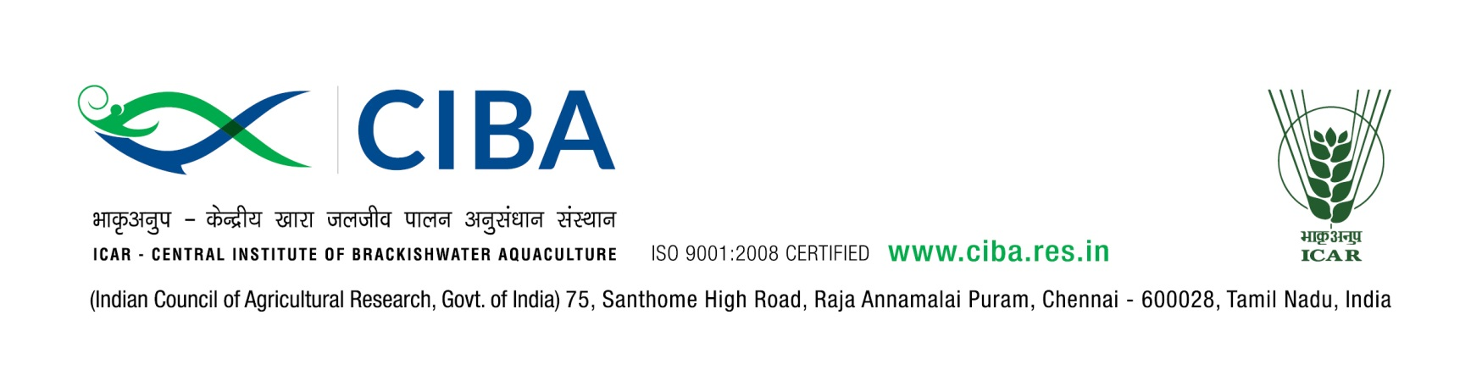
WALK–IN–INTERVIEW

The following posts are to be filled purely on temporary basis under “Network project on Agricultural Bioinformatics and Computational Biology” project at this Institute.

Posts | Young Professional II – One Post
Date & Time of Interview | 19th November 2019 at 10.30 a.m.
Project Name | Network project on Agricultural Bioinformatics and Computational Biology
Duration | Upto March 2020 / co-terminus with the project
Essential  Qualification | Ph.d / M.Sc./ M.Phil/M.Tech/B.Tech (Bioinformatics/Computational biology) With 1st division or 60% marks or equivalent overall grade point average with at least two years of research experience in the relevant subject.
Job Profile and place of posting | Young Professional II will be responsible for providing assistance to project activities at ICAR-CIBA, Chennai
Emoluments | Rs.25000/- p.m. (Consolidated)
Age Limit | Maximum 40 years for men and 45 years for women as on date of interview. Age limits are relaxable for SC / ST / OBC candidates as per rules.

The Candidates fulfilling the above criteria may send their application in the prescribed proforma only through e-mail to ashok@ciba.res.in positively on or before 15th November, 2019. Applications received after the above said prescribed last date will not be entertained under any circumstances. The applicant should indicate “Application for YP-II” in the subject line of his/her email. Except for the prescribed application proforma, please DO NOT attach any other documents along with your application. Applications submitted through private job web portals will not be considered. Communication will be sent only to the short-listed candidates by email to attend the interview at later date.
The candidates who have received mail should appear for the interview with the filled-in application, original and photocopies of certificates alongwith passport size photograph. Director, CIBA reserves right to accept or reject any applications. CIBA does not enter into correspondence with the applicants for not calling them for interview. TA / DA will not be paid for attending the interview.

Principal Investigator

Application for the post of Young Professional -II

1. | Name of the project
2. | Name of the post applied
3. | Name (in Block Letters)
5. | Date of Birth and age
6. | Sex: M/F
7. | Marital Status
8. | Category: SC/ST/OBC  (Scan copy of certificate to be attached)
9. | Father/Husband Name
10. | Address for Correspondence
11. | Phone No.
12. | E-mail Address

- Qualification: (Scan copies of certificates to be attached)

Examination | Subject | Name of Institution | Year of Passing | % of marks/ GPA obtained
Doctorate

Post-Graduation
Graduation
Higher Secondary
SSLC or Equivalent
Others if any

14. | Whether NET / GATE qualified :  If yes, date of passing  (Scan copy of certificate to be  attached) | Yes / No
15. | No. of research papers / conference papers / other papers published
16. | Title of the paper in SCI Journal :
17. | i) Working Experience(if any)  ii) Whether currently employed  If employed in State / Central Govt., Autonomous Body, PSU, NOC is required
18. | Name and address of two referees along with phone number and e.mail ID

19. Statement of Purpose in Maximum one page (About yourself, reason for opting this
job and experience)

DECLARATION

I hereby declare that I have carefully read and understood the instructions and particulars on this application and that all entries in this form are true to the best of my knowledge and belief.

Signature
Date:

Place:

