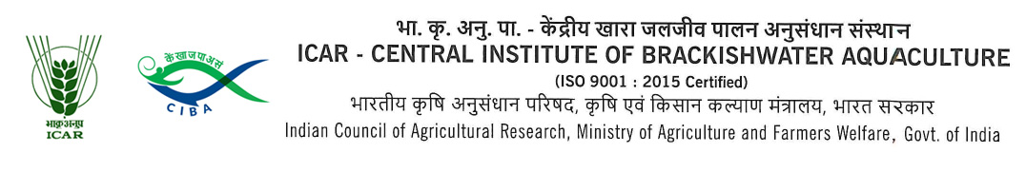
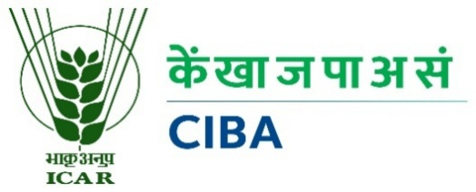

F.No.39(373)/2026-Admn Dated :11.05.2026
F.No.39(346)/2024-Admn Dated :03.08.2026
Applications are invited from eligible candidates for recruitment of Project Associate-1 (1 No.) purely on a temporary basis under the DBT-funded project at this Institute.

Post | Project Associate-1 (One Post)
Project name | IoT based water and soil health monitoring systems with affordable indigenous sensors for intensive aquaculture
Duration | Till 23rd May 2027 or co-terminus with project
Funding Agency | DBT
Essential qualification | - M.F.Sc degree in Aquatic Environmental Management  OR  - M.Sc in Chemistry/Soil Chemistry/ Environmental Sciences  OR  - Bachelor’s degree in Engineering or Technology with a specialization in Electronics & Communications/ Computer Science OR  - M.Sc in Data Science with experience in IoT and Artificial Intelligence
Desirable | - A minimum of one year of research experience in a relevant field from a recognized university.  - Candidates with NET qualification
Emoluments | Rs. 39,370/- per month (Rs.31,000/- +27% HRA)
Age limit | Maximum 35 years for men and 40 years for women as on the date of the interview. Relaxation of SC candidate will be as per the rules
Place of Post | ICAR- CIBA, Chennai
Last Date for submission of biodata | 13th August, 2026
Date & Time of interview | Will be intimated to the shortlisted candidates by mail
Mode of Interview | Physical mode/ Suitable online platform

The candidates fulfilling the above criteria may send their application in prescribed proforma only along with biodata through e-mail to recruitmentcell.ciba@gmail.com on or before 13.08.2026. Applications received after the above said prescribed last date will not be entertained under any circumstances. Communication will be sent to the short-listed candidates only by email to attend the interview. The candidates who have received mail should appear for online or offline interview with required documents. Director, CIBA reserves right to accept or reject any applications. ICAR-CIBA does enter into correspondence with the applicants for not calling them for interview.

Guidelines for filling the application
- Application form may be downloaded and clearly hand filled/typed by the applicant.
- Dully filled and signed application forms should be attached with all the required documents (degree certificates, experience certificates etc.) failing which the application of the candidate may be rejected. Supporting documents should be serially numbered as Annexures and referred in the application form at relevant places.
- All the above documents should be uploaded as single merged pdf file.
- The PDF file should be named as IOTSensors << Applicant First name >>_13082026.pdf
- The pdf file should be sent as attachment to the e-mail ID recruitmentcell.ciba@gmail.com

Principal Investigator

Application for the post of Project Associate -1

 | Name of the Project | IoT based water and soil health monitoring systems with affordable indigenous sensors for intensive aquaculture
 | Name (in Block Letters)
 | Date of Birth and Age
 | Sex: M/F
 | Marital Status
Category: SC/ST/OBC
(Scan copy of certificate to be attached)
 | Email ID
 | Address for Correspondence
 | Phone No.

10. Qualifications: (Scan copies of certificates to be attached)

Examination | Subject | Name of Institution | Year of Passing | % of marks/ GPA obtained
Doctorate
- Pre-thesis submitted
- Thesis submitted
- Degree awarded
Post-Graduation
Graduation

11. | Whether NET / GATE qualified :  If yes, date of passing  (Scan copy of certificate to be  attached) | Yes / No
12. | Research Papers published in SCI Journal (Give the citation)
13. | Patents filed/granted (Furnish the details)
14. | University Awards/Medals/Conference Best Presentation Awards (Furnish the details)
15. | Work experience in project/Industry/Aquaculture Experience
16. | Post graduate Thesis/Dissertation Title
17 | Abstract (max 150 words)
18. | PhD Thesis/Dissertation Title
19. | Abstract (max 250 words)

DECLARATION
I hereby declare that the information furnished by me in this application is true and correct to the best of my knowledge and belief. I will produce supporting documents as and when required. If any information is found to be false or misleading, my candidature is liable to be cancelled at any stage of the recruitment process.
Signature
Date :

Place:

